Introductory thoughts
Tactile sensing has been a component of robotics for roughly as long as vision. However, in comparison to vision, for which great strides have been made in terms of hardware and software and which is now widely used in industrial and mobile robot applications, tactile sensing always seems to be “a few years away” from widespread utility. Therefore, before reviewing the technologies and approaches available it is worthwhile to consider some basic questions:
- How important is tactile sensing?
- What is it useful for?
- Why does it remain comparatively undeveloped?

In Nature, tactile sensing is evidently an essential survival tool. Even the simplest creatures are endowed with large numbers of mechanoreceptors for exploring and responding to various stimuli. In humans, tactile sensing is indispensable for manipulation, exploration and response. A couple of quick thought exercises illustrate the point: When our fingers are numbed by cold we become clumsy, so that simple manipulation tasks, like unbuckling a boot, are an exercise in frustration. Our muscles, snug in our coat sleeves, are only slightly affected but our cutaneous mechanoreceptors are anesthetized. For exploration, we rapidly assimilate tactile information about material and surface properties (e.g., hardness, thermal conductivity, friction, roughness) to help us identify objects. We may have difficulty distinguishing leather from pleather™ by sight, but not by touch! The importance of tactile response, whether to a gentle touch or an impact, is seen in the damage that patients with peripheral neuropathy (e.g., as a complication of diabetes) accidentally do to themselves.
Table I. Uses of tactile sensing in robotics
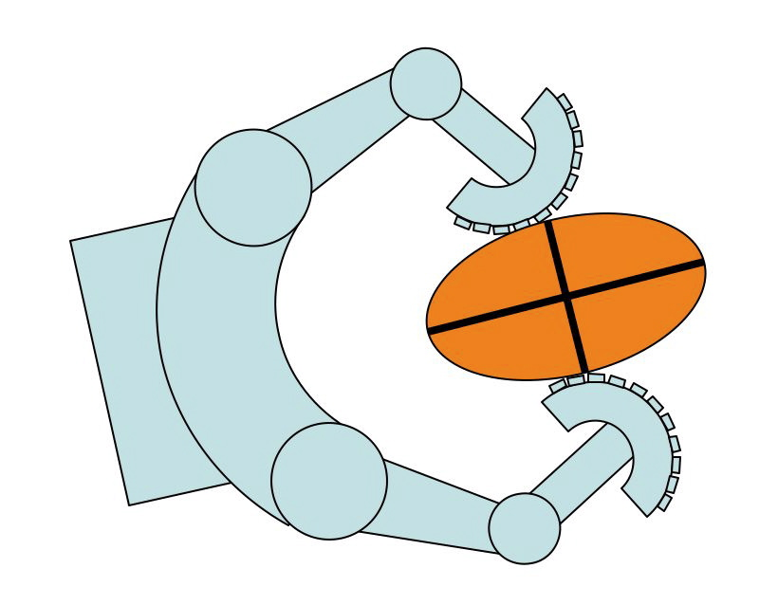 | Manipulation: Grasp force control; contact locations and kinematics; stability assessment.
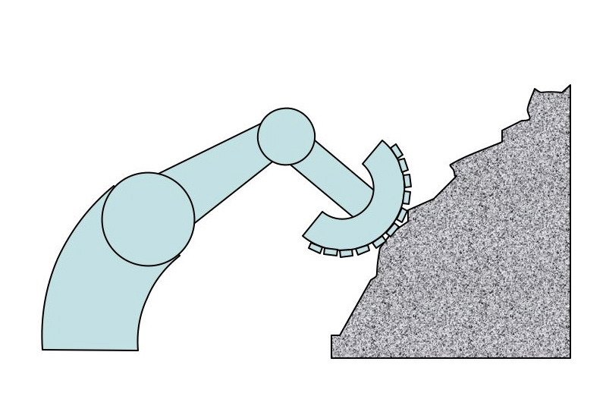 | Exploration: Surface texture, friction and hardness; thermal properties; local features.
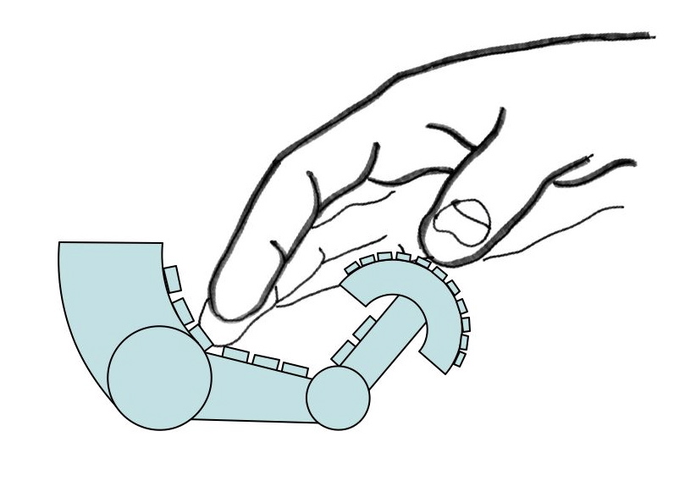 | Response: Detection and reaction to contacts from external agents.

As table I indicates, the same functional categories apply to robots. However, in comparison to animals, with thousands to millions of mechanoreceptors per square centimeter of skin [cite?], even the most sophisticated robots are impoverished. One reason for the slow development of tactile sensing technology as compared to vision is that there is no tactile analog to the CCD or COMS optical array. Instead, tactile sensors elicit information through physical interaction. They must be incorporated into gripping or “skin” surfaces with compliance, for conforming locally to surfaces, and adequate friction for handling objects securely. The sensors and skin must also be robust enough to survive repeated impacts and abrasions. And unlike an image plane, tactile sensors must be distributed over the robot appendages, with particularly high concentrations in areas such as the fingertips. The wiring of tactile sensors is consequently another challenge.

A second set of difficulties arises from the inherently multi-modal nature of tactile sensing. In humans, there are four main types of mechanoreceptors which can be classified according to whether they are slow- or fast-adapting and whether they have large or small receptive fields [cite]. For example, when you hold your fingertips against the edge of the table you can feel the corner as a continuing effect; the receptors that are primarily responsible for the sensation are slow-adapting Meissner and Merkel corpuscles, which detect local pressure and skin-stretch. In contrast, the detection of surface scratches in the tabletop requires motion of the fingertips across the surface, which excites the fast-adapting Pacinian corpuscles. For robots to make full use tactile information a similarly multi-modal approach, often employing different transducers, is required.

Despite the challenges associated with tactile sensing, interactive and multi-modal as it is, considerable progress in sensor design and deployment has been made over the last couple of decades. In the following sections we review the main functional classes of tactile sensors and discuss their relative strengths and limitations. Looking ahead, new fabrication techniques offer the possibility of artificial skin materials with integrated sensors and local processing for interpreting sensor signals and communicating over a common buss to reduce wiring.

We conclude with…

recommendations…

Tactile sensor types
Single sensors – are most commonly force/torque sensors, dynamic sensors and thermal sensors.

Force/torque sensors

are often used in combination with tactile arrays to provide information for force control. A single force/torque sensor can sense loads anywhere on the distal link of a manipulator and, not being subject to the same packaging constraints as a “skin” sensor, can generally provide more precise force measurements at higher bandwidth. If the geometry of the manipulator link is defined, and if single-point contact can be assumed (as in the case of a robot finger with a hemispherical tip contacting locally convex surfaces), then a force/torque sensor can provide information about the contact location by ratios of forces and moments in a technique called “intrinsic tactile sensing” [Salisbury, Bicchi].

Dynamic tactile sensors

The most common dynamic tactile sensors are small accelerometers at the fingertips or in the skin of a robotic finger. They function roughly like pacinian corpuscles in humans [cite] and have a correspondingly large receptive field so that one or two skin accelerometers suffices for an entire finger. These sensors are particularly effective for detecting the making and breaking of contact, the onset of slip and the vibrations associated with sliding over textured surfaces.

A second type of dynamic tactile sensor is the stress rate sensor [cite Howe, Son]. If a fingertip is sliding at a speed of a few centimeters/second over small asperities (bumps or pits) in a surface, the transient changes in stresses in the skin will be significant. A piezoelectric polymer such as PVDF [cite] that produces a charge in response to strain can be used to produce currents proportional to the rage of change of stress:

[could put a small diagram here of dynamic tactile sensors + stress rate circuit]

Thermal sensors

Thermal sensors are an important component of the human ability to identify the materials of which objects are made (think of how metal feels cool to the touch compared to wood) but little used in robotics. Human thermal sensing involves detecting thermal gradients in the skin, which correspond to both the temperature and the thermal conductivity of an object. Robotic thermal sensors have involved peltier junctions in combination with thermocouples or thermistors [cite].
Difficulties have been encountered in obtaining sufficient resolution and time response when using them to distinguish among different materials [cite ]

See a bit more at

Sensor arrays

- there are various possible ways of organizing tactile sensor arrays. From a functional standpoint, the primary concerns include:

- What is being measured (e.g., surface pressure or shear tractions, deformations, local geometry)
- What is the transduction method (e.g., piezo resistive, capacitive, optical)
- What are the mounting provisions (e.g., rigid or compliant, flat or curved)
- What are the expected levels of sensor resolution, accuracy and dynamic range (e.g. point to point spacing, minimum detectable stimulus, hysteresis, frequency response).

Uniaxial arrays

Pressure sensitive arrays
Piezo resistive polymer or elastomer
Strain gages
Capacitive
Optical displacement
Optical FIR
Magnetostrictive

Multiaxial arrays

Pressure and shear sensitive arrays
(Ando 2001) – multiaxial array, ultrasonic

Skin deformation sensors

Multi-modal arrays

Ando, S. S., H.; Yonenaga, A.; Terao, J. (2001). "Ultrasonic six-axis deformation sensing." Ultrasonics, Ferroelectrics and Frequency Control, IEEE Transactions on 48(4): 1031-1045.
In this paper, we describe a newly developed deformation sensing scheme in a soft medium, which is based on precise encoding and decoding of deformation components into ultrasound wavefronts. It can detect three translational components and three rotational components of displacement around a transmitter position nearly simultaneously. We assume a cell structure that consists of a 2x2 ultrasonic transmitter matrix and a 2x2 ultrasonic receiver matrix, which are placed face to face at a distance of a few tens of wavelengths. All of the transmitter elements are driven sinusoidally and simultaneously, but they are switched into the same, reversed, or quadrature phases to generate a particular shape of wavefront on the receiver matrix. The receiver elements are connected in such a way to obtain amplitude and spatial gradients of the wavefront at a center of the receiver matrix. First, we describe the transduction theory for the six dimensions and show the orthogonality, locality, and simultaneity of this sensing scheme. Then, we describe the fabrication and experimental evaluation of the cell. We also describe a prototype tactile sensor in which a single cell is embedded in a flexible hemispherical fingertip-like body

